**Temperature and Humidity Sensor DHT11 and show it to TFT Display**

**Description**: In this project, we will show the temperature and humidity in TFT LCD Display with the help of DHT11(temperature and humidity sensor).

**Hardware Requirement:**

* Arduino Uno board
* Breadboard
* Jumper wire
* TFT LCD Display-8pin
* DHT11 (temperature and humidity sensor)

**DHT11 (temperature and humidity sensor):**

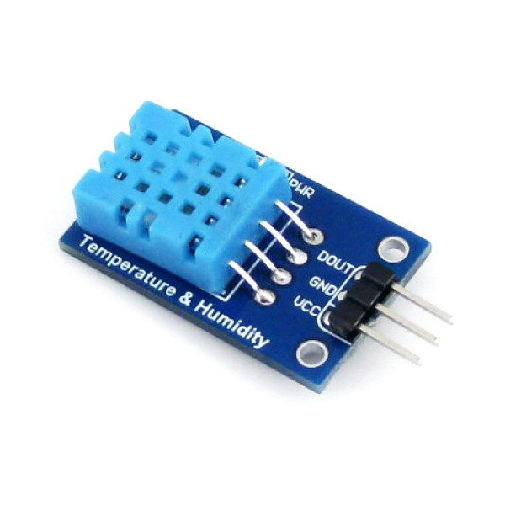

**Connection:**  Output pin connected to arduino’s pin-2;

**TFT display and it’s Connection**:

TFT Display:

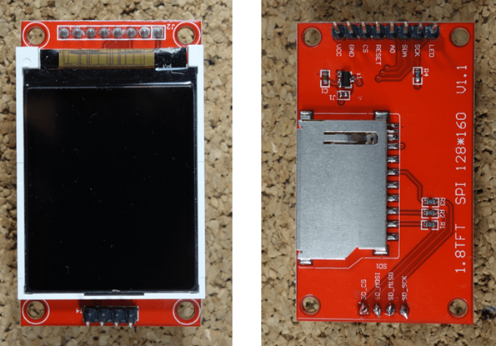

**Connection:**

| **1.8 TFT Display** | **Wiring to Arduino Uno** |
| --- | --- |
| LED | 3.3 V |
| SCK | 13 |
| SDA | 11 |
| A0 or DC | 9 |
| RESET | 8 |
| CS | 10 |
| GND | GND |
| VCC | 5 V |

Code:

| #include <SimpleDHT.h> #include<TFT.h> #include<SPI.h> #define cs 10 #define dc 9 #define rst 8    // create an instance of the library TFT tft = TFT(cs, dc, rst); // for DHT11,  // VCC: 5V or 3V // GND: GND // DATA: 2 int pinDHT11 = 2; SimpleDHT11 dht11(pinDHT11);  void setup() {  Serial.begin(9600);  tft.begin();   // clear the screen with a black background  tft.background(0, 0, 0);  //set the text size  tft.setTextSize(2); }  void loop() {  // start working...      // read without samples.  byte temperature = 0;  byte humidity = 0;  int err = SimpleDHTErrSuccess;  if ((err = dht11.read(&temperature, &humidity, NULL)) != SimpleDHTErrSuccess) {    return;  }    Serial.print((int)temperature); Serial.print(" *C, ");   Serial.print((int)humidity); Serial.println(" %");    // DHT11 sampling rate is 1HZ.  delay(1500);  int t=(int)temperature;  int h=(int)humidity;    tft.stroke(0,250,0);  tft.setTextSize(1);  tft.setCursor(5,25);  tft.print("Temperature :");   tft.setTextSize(2);  tft.setCursor(90,20);  tft.print(t);    tft.setTextSize(2);  tft.setCursor(120,20);  tft.print("*C");    tft.setTextSize(1);  tft.setCursor(5,55);  tft.print("Humidity :");   tft.setTextSize(2);  tft.setCursor(90,50);  tft.print(h);    tft.setTextSize(2);  tft.setCursor(120,50);  tft.print("%"); } |
| --- |

**OUTPUT:**

